FIELD REPORT
Introduction
Place: Anyomorem HC III
Location: Anyomorem, Lira city
Date of visit: 27th August 2026
- General observations
- The verification exercise was conducted with the full cooperation and support of the Facility In-Charge. The facility has a relatively high patient load, and the UgIFT support has contributed to improving its capacity to provide services to the community.
- Despite the improved capacity, the facility continues to face challenges related to staff accommodation, power supply, and adequacy of some equipment.
Special Notes
- All assets not engraved
- Staff accommodation: The facility has only two staff houses, which are inadequate to accommodate the number of staff deployed at the health center. Limited staff accommodation may affect staff retention, security, and the availability of staff to respond promptly to emergencies, particularly outside normal working hours.
- Power supply and equipment utilization: Frequent power blackouts affect the operation of the laboratory and may disrupt the delivery of laboratory services.
- Equipment documentation: Some equipment was supplied without user manuals, which may affect proper operation, routine maintenance, and troubleshooting by facility staff.
- Adequacy of delivery beds: The facility reported that the number of delivery beds is inadequate in relation to the number of patients served. Given the facility's patient load, additional delivery beds would help improve its capacity to provide maternity services efficiently.

The table below illustrates some physical status of the verified assets with photographic evidence.
Table XXX: Physical verification photos
ANYOMOREM HC III SIGN POST | No signpost
OUTPATIENT BLOCK | 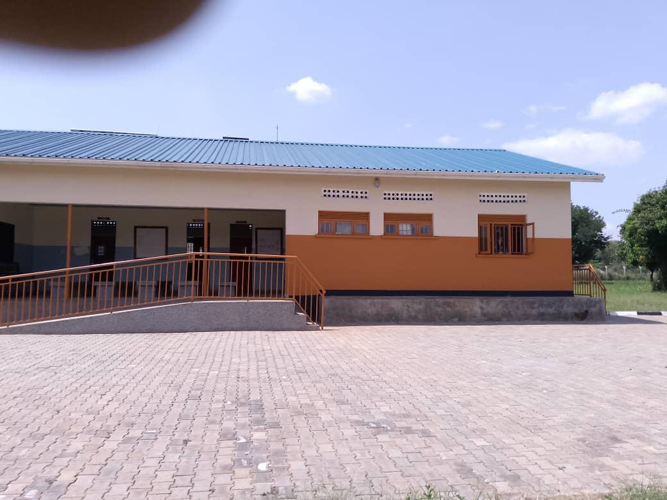
MATERNITY WARD/ BLOCK (FRONT VIEW) | 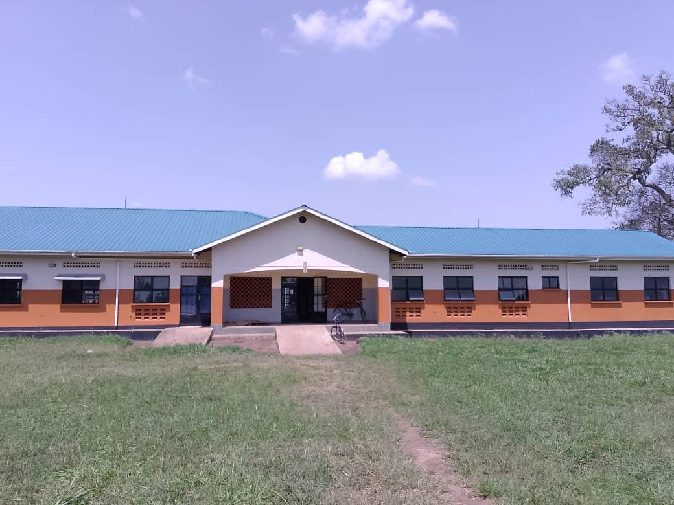
MATERNITY WARD/ BLOCK (BACK VIEW) | 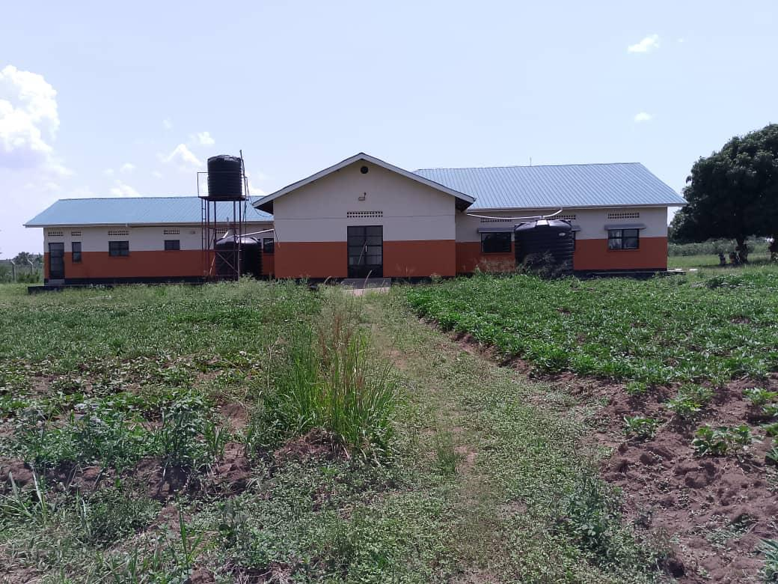
 | 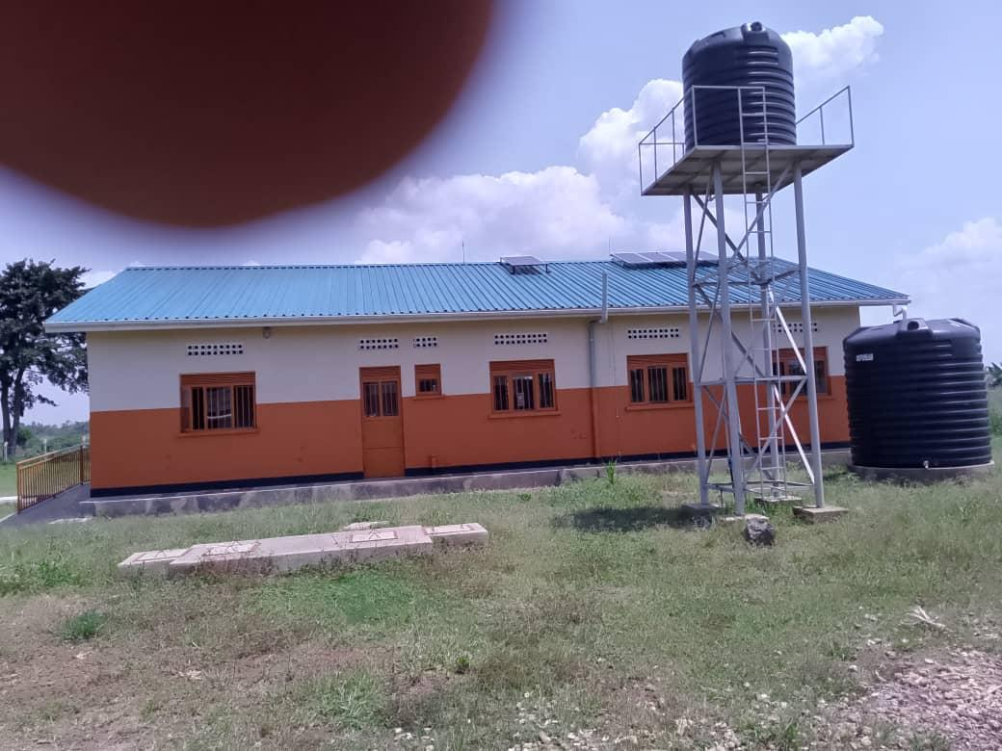
 | 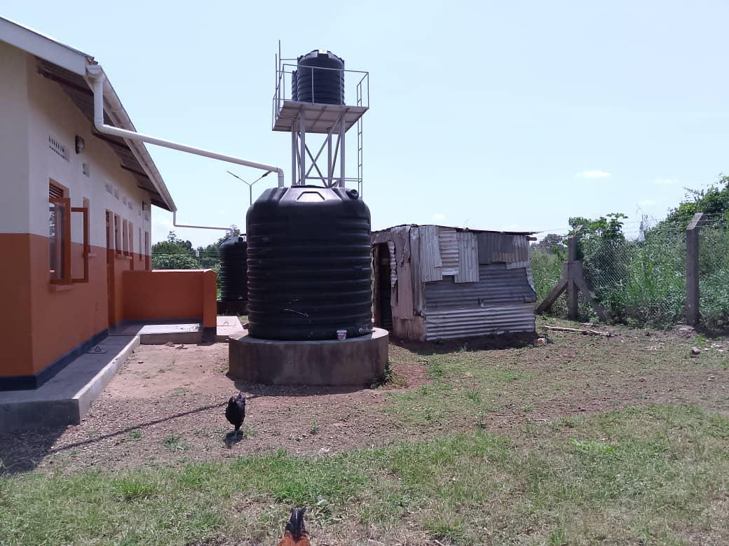
PLACENTA PIT | 